INTERNATIONAL CONFERENCE ON HEALTH AND

DISEASE MANAGEMENT (ICHDM 2026)

SASTRA DEEMED TO BE UNIVERSITY,KUMBAKONAM.

TITLE

AUTOMATED THYROID CANCER NODULE DETECTION AND SEGMENTATION IN ULTRASOUND IMAGES USING MODIFIED VGG-CNN AND FUZZY C-MEANS CLUSTERING

AUTHORS

NANDHINI SRI K, SHRI MADHURABASHINI M S, SOWNTHARYA G, VENKATESAN R

SUPERVISOR

VENKATESAN R

ASSOCIATE PROFESSOR

DEPARTMENT OF BIOMEDICAL ENGINEERING

BATCH NO : T952

Mode: Offline

Venue: 201 (Second floor) @SASTRA UNIVERSITY

Session & Time: II & 3:30 PM-5:30 PM

AUTOMATED THYROID CANCER NODULE DETECTION AND SEGMENTATION IN ULTRASOUND IMAGES USING MODIFIED VGG-CNN AND FUZZY C-MEANS CLUSTERING
K Nandhini sri¹, M S Shri Madhurabashni¹, G Sowntharya¹, R Venkatesan^{1*}
¹ Department of Biomedical Engineering, E. G. S. Pillay Engineering College, Nagapattinam,
Tamil Nadu, India – 611002
Corresponding author email id: vengatesan.r@egspec.org
Abstract
Thyroid cancer is a significant endocrine malignancy in which early and accurate diagnosis is essential for effective treatment. Ultrasound imaging is the primary diagnostic tool for thyroid evaluation due to its safety, affordability, and non-invasive nature. However, ultrasound images are often degraded by speckle noise, low contrast, and unclear boundaries, making manual interpretation challenging and highly dependent on radiologist expertise. To address these limitations, this study proposes an automated computer-aided diagnosis (CAD) system for thyroid tumor detection, classification, and segmentation.
The framework integrates a Modified VGG-based Convolutional Neural Network (VGG-CNN) with Fuzzy C-Means (FCM) clustering. Preprocessing techniques such as noise reduction, contrast enhancement, and normalization are first applied to improve image quality. The optimized VGG-CNN model extracts deep features and classifies nodules as benign or malignant with improved computational efficiency. For precise tumor localization, FCM clustering is used to segment nodules by effectively handling uncertainty and overlapping intensity regions common in ultrasound images.
Experimental results demonstrate superior accuracy, sensitivity, specificity, and segmentation performance compared to existing methods. The proposed system supports radiologists by reducing diagnostic workload and improving early thyroid cancer detection.
Keywords
Thyroid Cancer, Ultrasound Imaging, Computer-Aided Diagnosis (CAD), Modified VGG-CNN, Fuzzy C-Means (FCM), Image Preprocessing, Tumor Segmentation, Deep Learning

Fwd: ICHDM - 2026 Registration Confirmation
Inbox

Dr. R Venkatesan Rethinasamy M.Tech.,PhD | 10:52 (32 minutes ago)
to me

---------- Forwarded message ---------
From: ICHDM 2026 SASTRA <ichdm2026@sastra.ac.in>
Date: Fri, Feb 6, 2026 at 5:00 PM
Subject: ICHDM - 2026 Registration Confirmation
To: <vengatesan.r@egspec.org>

Dear K.Nandhini Sri,
Thank you for registering for the “International Conference on Health and Disease Management” (ICHDM-2026), to be held on February 26th and 27th, 2026, under the Oral Presentation category. Your Unique ID: T952. Kindly join the WhatsApp group through this link:https://chat.whatsapp.com/JbIdU4dRXhILSMyEYFBsfb

Regards,
Organizing Team
ICHDM-2026

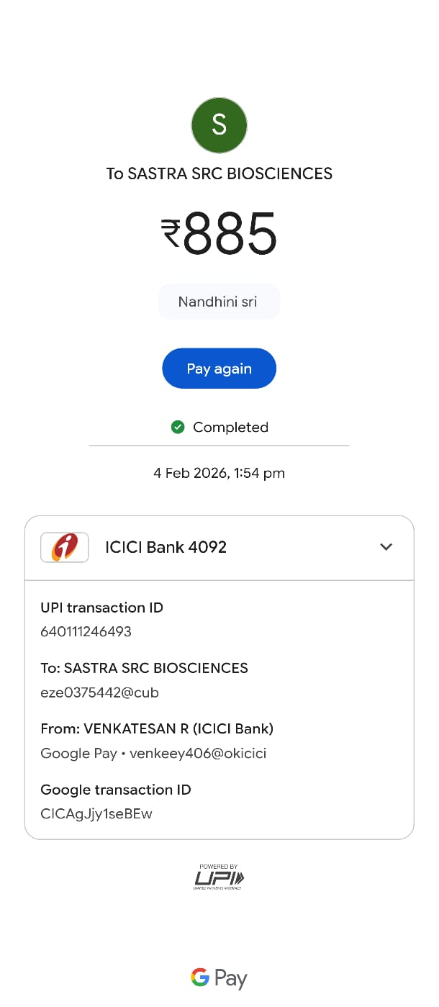

PRESENTATION @ ICHDM 2026

